# **Notice of unknown service line material**

### **The Town of Fordoche** is focused on protecting the health of every household in our community. This notice contains important information about your drinking water. The **Town of Fordoche** is working to identify service line materials throughout the water system but has yet to determine the material of the service line at your location. Because your service line material is unknown, there is the potential that some or all of the service line could be made of lead or galvanized pipe that was previously connected to lead. People living in homes with a lead or galvanized pipe previously connected to a lead service line have an increased risk of exposure to lead from their drinking water. For information on sources of lead in drinking water, please visit <https://www.epa.gov/ground-water-and-drinking-water/basic-information-about-lead-drinking-water#getinto>. Please share this information with anyone who drinks and/or cooks using water at this property. Late 2025, the Town of Fordoche will be installing water meters to every service line. At that point, we will be able to identify the type of line from the town’s connection to your property.

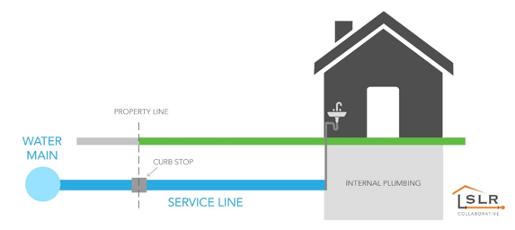

## Health effects of lead

Exposure to lead in drinking water can cause serious health effects in all age groups. Infants and children can have decreases in IQ and attention span. Lead exposure can lead to new learning and behavior problems or exacerbate existing learning and behavior problems. The children of women who are exposed to lead before or during pregnancy can have increased risk of these adverse health effects. Adults can have increased risks of heart disease, high blood pressure, kidney, or nervous system problems.

## Get your child tested to determine lead levels in their blood.

Although there is no confirmation of having a lead service line, you may wish to speak with a healthcare provider to see if your child’s blood lead level is elevated and/or if there is a need for blood testing, if you are concerned about potential exposure. Please visit <https://www.cdc.gov/nceh/lead/advisory/acclpp/actions-blls.htm> for information on these actions.

## Steps you can take to reduce lead in drinking water.

Below are recommended actions that you may take, separately or in combination, if you are concerned about lead in your drinking water. The list also includes where you may find more information and is not intended to be a complete list or to imply that all actions equally reduce lead in drinking water.

* **Clean your aerator.** Regularly remove and clean your faucet’s screen (also known as an aerator). Sediment, debris, and lead particles can collect in your aerator. If lead particles are caught in the aerator, lead can get into your water.
* **Use cold water**. Do not use hot water from the tap for drinking, cooking, or making baby formula as lead dissolves more easily into hot water. Boiling water does not remove lead from water.
* **Flush your faucet.** The more time water has been sitting in pipes, the more lead it may contain. Before drinking or using water for cooking, flush your home’s pipes by running the tap until the water temperature changes (typically ~30 seconds).
* **For more information on reducing lead exposure** from your drinking water and the health effects of lead, visit EPA’s website at <http://www.epa.gov/lead>.

## Identifying service line material

EPA has developed an online step-by-step guide to help people identify lead pipes in their homes called Protect Your Tap: A Quick Check for Lead. It is available at: <https://www.epa.gov/ground-water-and-drinking-water/protect-your-tap-quick-check-lead>. For additional information, including updates on our service line identification efforts and information on how to identify the service line material, please contact us at Town of Fordoche 225-637-3112 or clerk@fordoche.org